Model Metrics For Stroke Prediction Model

Model 1: KNeighborsClassifier using Grid Search CV for Hyperparameter optimization

Grid Search CV:

Best Score:0.9668208532059281

Best Parameters: {'n_neighbors': 8}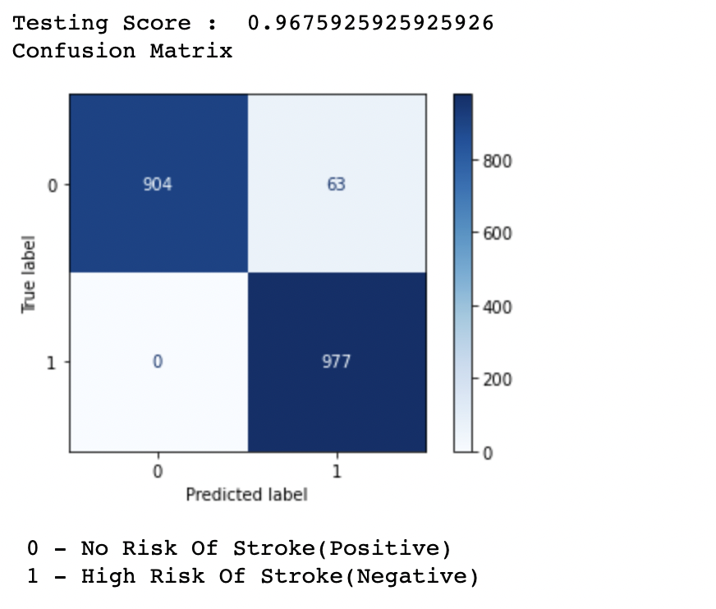

Model Outcome:

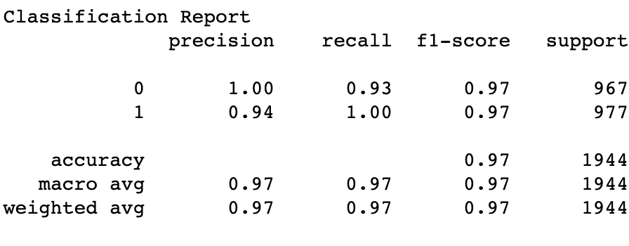

Model 2: Decision Tree

Model Outcome:

The test score: 0.970679012345679

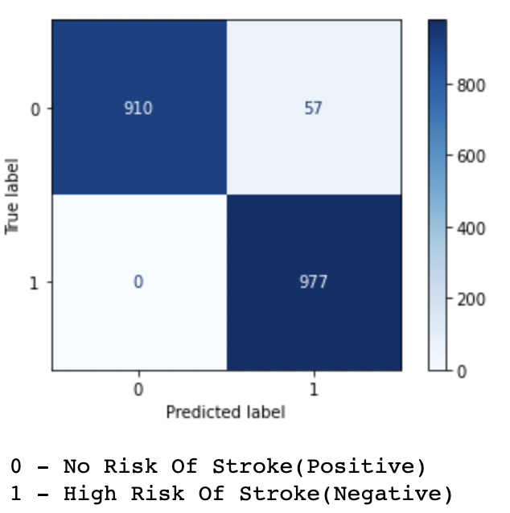

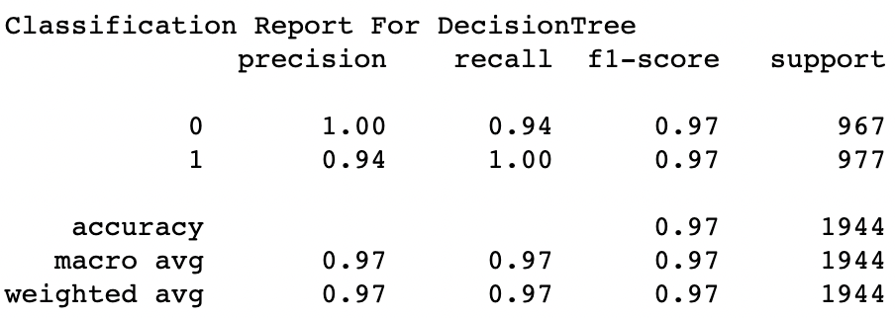

Model 3: RandomForestClassifier using RandomSearchCV for Hyperparameter optimization

RandomSearchCV Hyperparameters: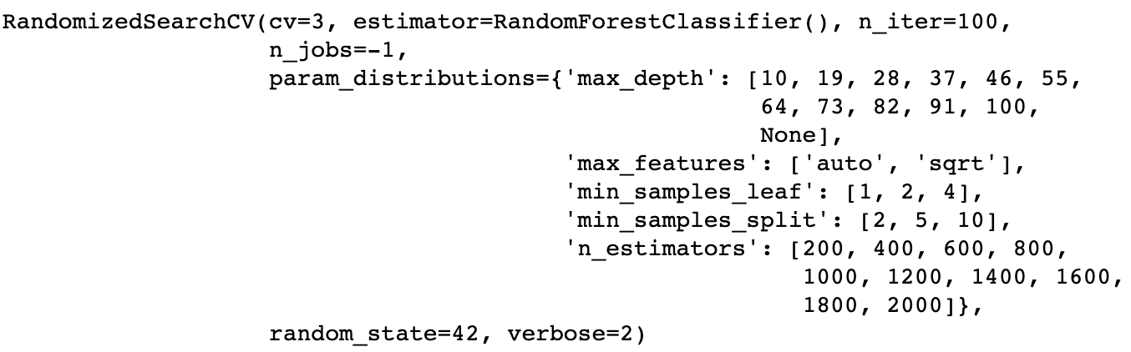

Model Outcome:

Best Score : 0.9763374485596708

RandomForestClassifier(max_features='sqrt', n_estimators=800)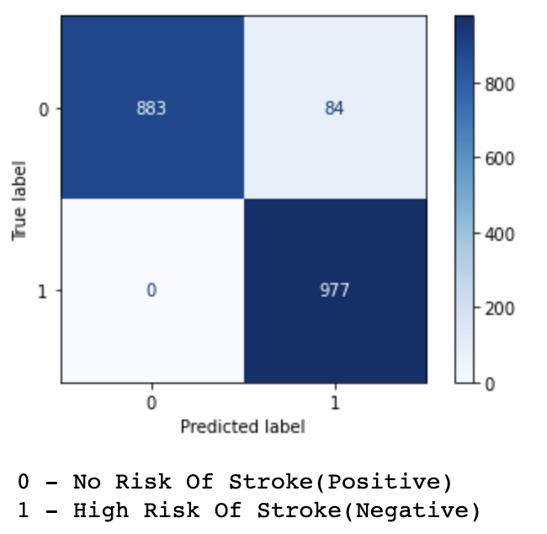

Test score for RandomForestClassifier is : 0.9567901234567902

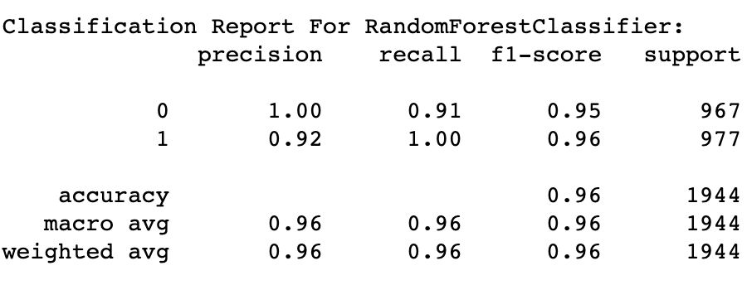

Model 4: Logistic Regression

Model Outcome:

Test Score: 0.7705761316872428

